LAB Logbook

Lab 1
CODE:
import numpy as np
SID = 23750107
last_two_digits = int(str(SID)[-2:])
if last_two_digits < 10:
num_elements = last_two_digits + 100
else:
num_elements = last_two_digits
a = np.arange(num_elements)
a_2d = a.reshape(1, -1)
print(a_2d)
b = a_2d.copy()
print(b)
print(a_2d.shape)
print(b.shape)
OUTPUT:
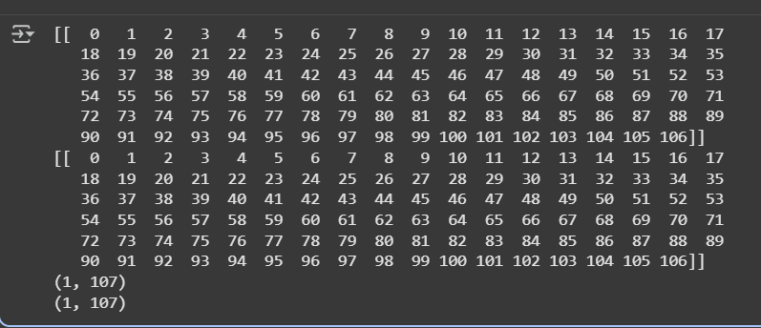
Lab 2
CODE:
import pandas as pd
data = pd.DataFrame({
"relationship": ["Husband", "Wife", "Own-child", "Not-in-family", "Husband", "Wife"],
"hours-per-week": [40, 50, 60, 20, 55, 45]
})
n = 10
def reduce_hours(x):
return x - n
data["reduced_hours"] = data["hours-per-week"].apply(reduce_hours)
grouped_original=data.groupby(["relationship","hours-per-week"]).size().reset_index(name="count")
grouped_reduced=data.groupby(["relationship", "reduced_hours"]).size().reset_index(name="count")
print("Original Grouping (relationship + hours-per-week):")
print(grouped_original, "\n")
print("Reduced Grouping (relationship + reduced_hours):")
print(grouped_reduced)
OUTPUT:
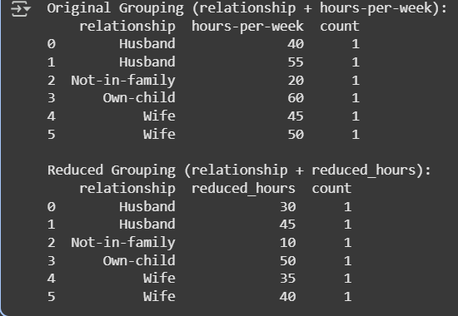
Lab 3
CODE:
import pandas as pd
import matplotlib.pyplot as plt
# Example DataFrame with columns 0-9
# Replace this with your actual dataset
data = pd.DataFrame({
0: [1, 2, 3, 4, 5, 6, 7, 8, 9, 10],
1: [10, 9, 8, 7, 6, 5, 4, 3, 2, 1],
2: [5, 4, 3, 2, 1, 0, -1, -2, -3, -4],
3: [2, 3, 2, 3, 2, 3, 2, 3, 2, 3],
4: [1, 3, 5, 7, 9, 11, 13, 15, 17, 19],
5: [2, 4, 6, 8, 10, 12, 14, 16, 18, 20],
6: [3, 6, 9, 12, 15, 18, 21, 24, 27, 30],
7: [1, 4, 7, 10, 13, 16, 19, 22, 25, 28],
8: [0, 1, 0, 1, 0, 1, 0, 1, 0, 1],
9: [5, 3, 1, -1, -3, -5, -7, -9, -11, -13]
})
# Select the two columns from your SID
col1, col2 = 0, 1
plt.figure(figsize=(8,6))
plt.scatter(data[col1], data[col2], c='blue', label=f'Col {col1} vs Col {col2}')
plt.xlabel(f'Column {col1}')
plt.ylabel(f'Column {col2}')
plt.title(f'Bicolour Features Interaction Diagram: Col {col1} vs Col {col2}')
plt.legend()
plt.grid(True)
plt.show()
OUTPUT:
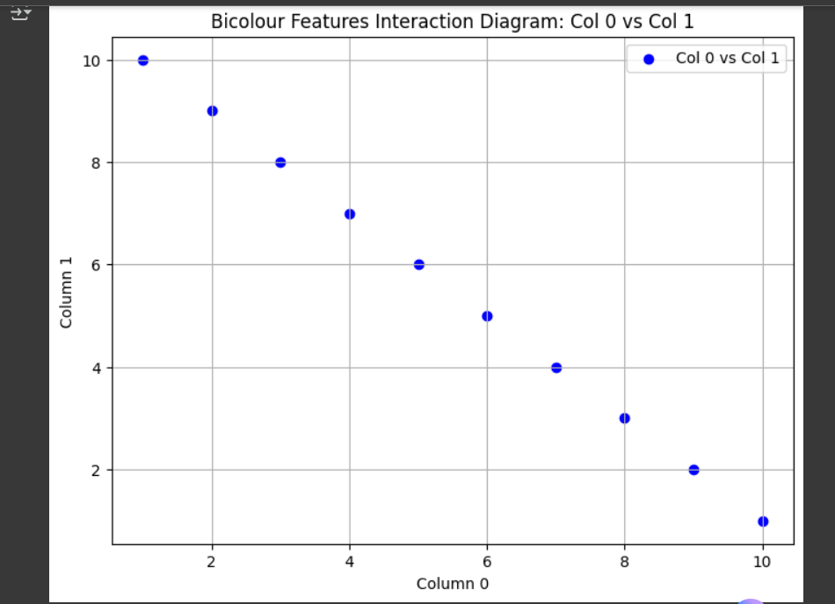

Lab 4
CODE:
import numpy as np
from tensorflow.keras.models import Sequential
from tensorflow.keras.layers import Dense
from tensorflow.keras.optimizers import Adam
from sklearn.model_selection import train_test_split
from sklearn.metrics import mean_absolute_error
from sklearn.preprocessing import MinMaxScaler
X = np.random.rand(1000, 10) # 10 input features
y = np.random.rand(1000, 1) # 1 target variable
scaler = MinMaxScaler()
X_scaled = scaler.fit_transform(X)
X_train, X_test, y_train, y_test = train_test_split(X_scaled, y, test_size=0.2, random_state=42)
model = Sequential()
model.add(Dense(10, activation='relu', input_shape=(X.shape[1],))) # First hidden layer
model.add(Dense(5, activation='relu')) # Second hidden layer
model.add(Dense(1)) # Output layer
model.compile(optimizer=Adam(), loss='mae', metrics=['mae'])
model.summary()
history = model.fit(X_train, y_train, epochs=10, validation_split=0.2)
mae = model.evaluate(X_test, y_test, verbose=0)[1]
print(f"Test MAE: {mae:.4f}")

OUTPUT:

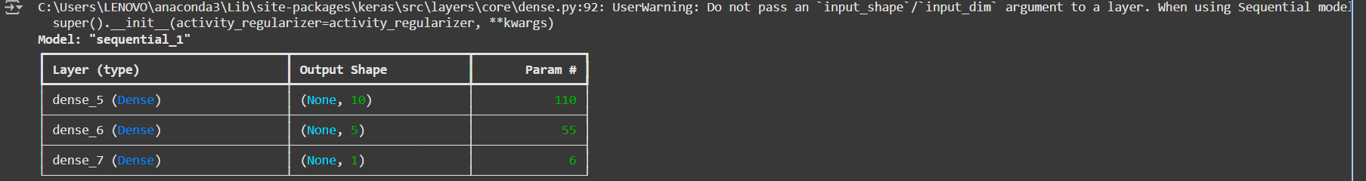

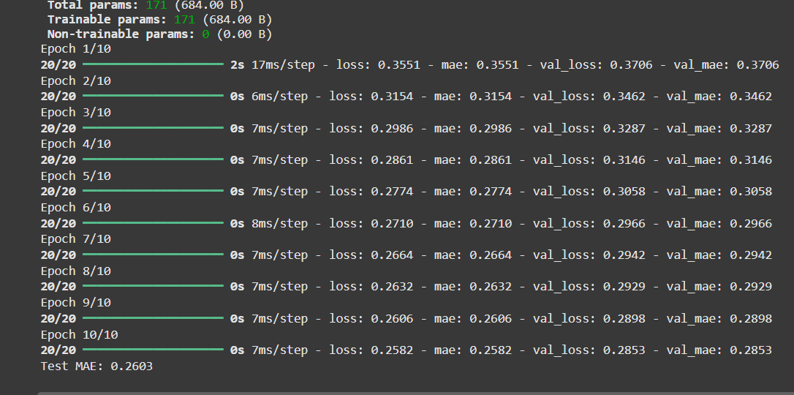

Lab 5
CODE:
import tensorflow as tf
from tensorflow.keras import layers, models
from tensorflow.keras.datasets import cifar10
import matplotlib.pyplot as plt
# Load dataset
(x_train, y_train), (x_test, y_test) = cifar10.load_data()
x_train, x_test = x_train / 255.0, x_test / 255.0
# Build CNN
model = models.Sequential([
layers.Conv2D(32, (5, 5), activation='relu', input_shape=(32, 32, 3)),
layers.MaxPooling2D((2, 2)),
layers.Conv2D(64, (5, 5), activation='relu'),
layers.MaxPooling2D((2, 2)),
layers.Flatten(),
layers.Dense(64, activation='relu'),
layers.Dense(10)
])
# Compile model
model.compile(optimizer='adam',
loss='mean_squared_error',
metrics=['mae'])
# Model summary
model.summary()
# Train CNN
history = model.fit(
x_train, y_train,
epochs=10,
batch_size=50,
validation_data=(x_test, y_test)
)
# Evaluate
test_loss, test_mae = model.evaluate(x_test, y_test, verbose=2)
print(f"\nTest MAE: {test_mae:.4f}")
# Plot MAE
plt.figure(figsize=(8, 5))
plt.plot(history.history['mae'], label='Train MAE')
plt.plot(history.history['val_mae'], label='Validation MAE')
plt.title('Model MAE During Training')
plt.xlabel('Epoch')
plt.ylabel('MAE')
plt.legend()
plt.grid(True)
plt.show()
OUTPUT:
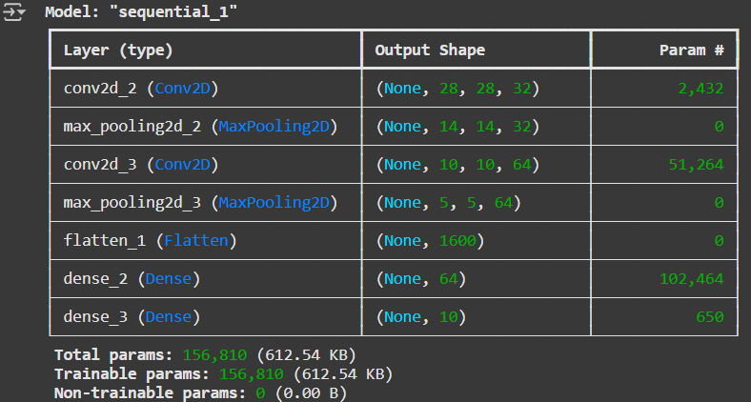
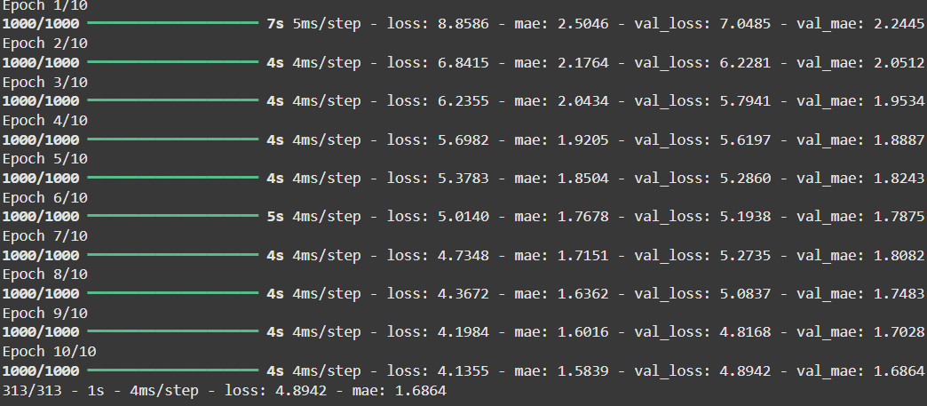

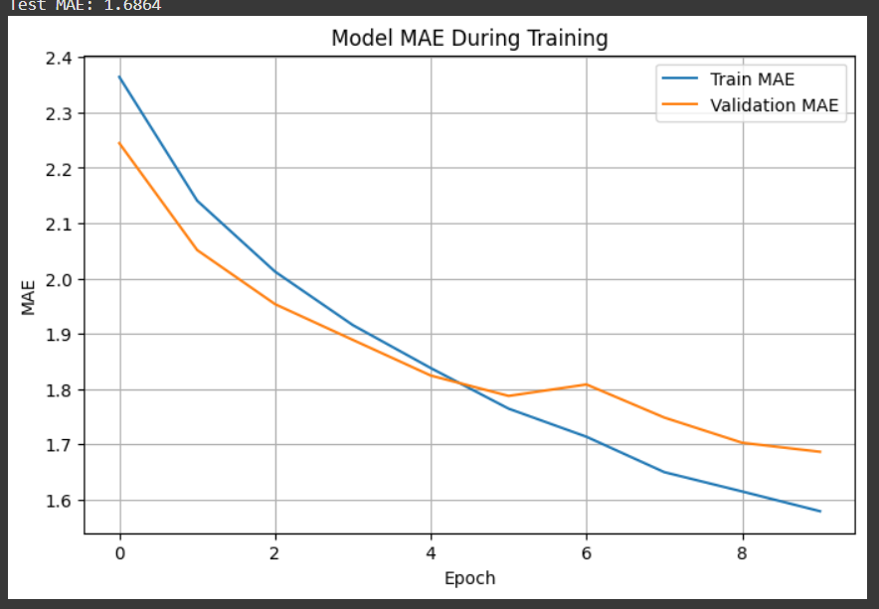

Lab 6
CODE:
import pandas as pd
import cufflinks as cf
cf.go_offline()
data2 = pd.read_csv('GOLD_2022_normalised.csv')
for col in data2.columns:
try:
data2[col] = pd.to_numeric(data2[col])
except:
pass
numeric_cols = data2.select_dtypes(include='number').columns
min_price = data2[numeric_cols].min().min()
max_price = data2[numeric_cols].max().max()
data2[numeric_cols] = (data2[numeric_cols] - min_price) / (max_price - min_price)
data_part = data2.iloc[375010 : 375010 + 10]
data_part.rename(columns={'High_x': 'High_Bid', 'Low_x': 'Low_Bid'}, inplace=True)
data_part[['High_Bid', 'Low_Bid']].iplot(
title='GOLD Price Chart (High_Bid vs Low_Bid)',
xTitle='Time (UTC)',
yTitle='Normalized Price',
theme='solar'
)

OUTPUT:
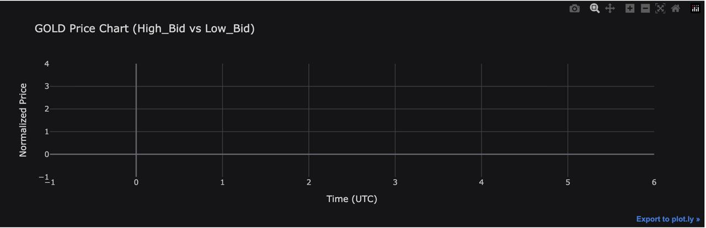

Lab 7

Lab 8

Lab 9

Lab 10

Lab 11

Lab 12

